A Large Language Model (LLM) is an advanced artificial intelligence system built on the Transformer architecture that understands, processes, and generates human-like text.
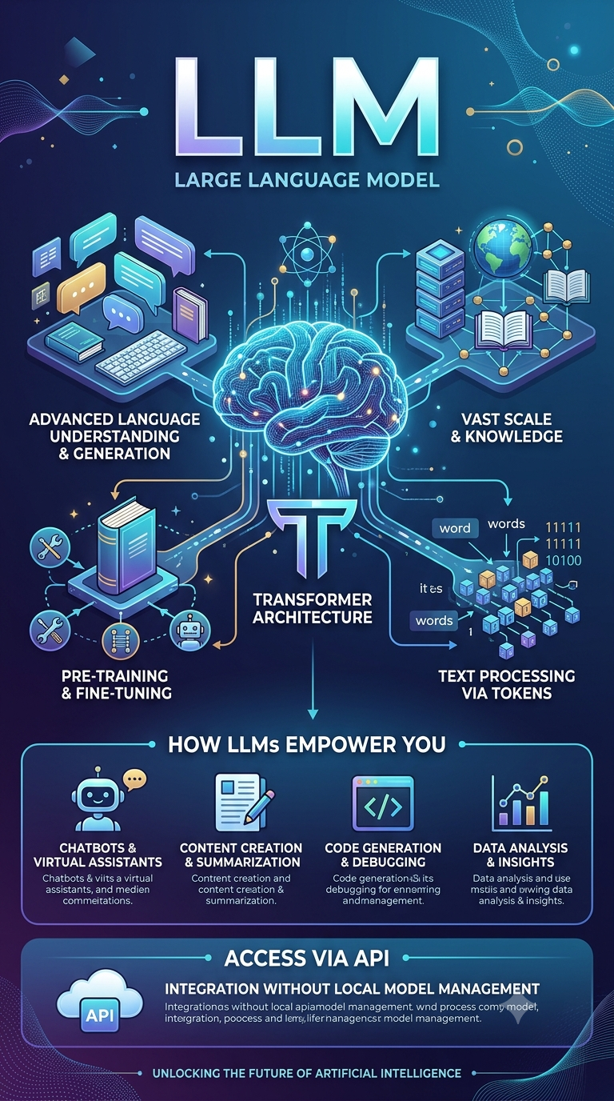
Core Definition:
- Scale ("Largeness"): Their capabilities stem from massive scale—specifically, billions of internal parameters trained on immense text datasets.
- How They Process Language: Rather than reading words directly, LLMs break text down into numerical tokens and convert them into mathematical vectors allowing the model to compute relationships and predict context.
- Two-Stage Training: They undergo pre-training on broad data to build a general knowledge base, followed by fine-tuning to specialize their behavior for specific tasks (like coding, customer support, or instruction following).
- Deployment & Access: Because their sheer size requires heavy compute infrastructure, LLMs are typically hosted in the cloud and accessed via APIs, letting developers integrate them into applications without running the models locally.
- Next-Token Prediction (The Core Mechanism): At their heart, LLMs are sophisticated probability engines. Given a sequence of tokens, they calculate the statistical likelihood of what token comes next, repeating this rapidly to generate coherent paragraphs, code, or summaries.
- Self-Attention Mechanism: The defining feature of the Transformer architecture. Self-attention allows the model to weigh the importance of different words in a sentence relative to each other—regardless of how far apart they are—which is how it grasps context, nuance, and grammar.
- Emergent Abilities & Context Windows: At massive scales, LLMs exhibit "emergent" skills they weren't explicitly programmed for, such as multi-step reasoning, translation, and zero-shot learning (performing a task with no prior examples). How much information they can actively consider at once is governed by their context window (short-term memory).
- RLHF (Reinforcement Learning from Human Feedback): Beyond standard fine-tuning, modern LLMs are aligned using human feedback to ensure their outputs are helpful, safe, and conversational rather than just raw text completions.

Core Concepts:
- Machine Learning-Based NLP: Early NLP systems used machine learning techniques to identify patterns in labeled datasets, enabling tasks such as spam filtering, sentiment analysis, and text classification.
- Deep Learning: A branch of machine learning inspired by the structure of the human brain. It powers advanced models such as RNNs and LSTMs, allowing them to understand sequences and tackle more complex language tasks.
- Transformers: Introduced in 2017 through the "Attention Is All You Need" paper, transformer architecture revolutionized NLP by enabling models to capture long-range dependencies and focus on the most relevant information within a text.
- Parameters (Weights): Internal numerical values that a model learns during training. These values determine how much importance is assigned to different features when making predictions or generating content.
- Pre-training: The process of training a model on massive amounts of diverse text data to build a broad understanding of language, grammar, and context.
- Fine-tuning: The process of adapting a pre-trained model to a specific task or domain by training it further on a smaller, specialized dataset.
- Tokens: The basic units of text processed by language models, which may include words, subwords, characters, or punctuation marks.
- Encoding and Decoding: Encoding converts text into numerical representations that machines can process, while decoding transforms those representations back into human-readable language.
- Vectors: Mathematical representations of words or tokens in a multidimensional space, where semantically similar terms are positioned closer together.
- LLM Deployment and APIs: Large Language Models are typically hosted on cloud infrastructure and made available to applications and developers through APIs, enabling integration into various products and services.

